Groundwater Level and Hydrochemical Analysis Using Data Science Techniques

Abstract
Groundwater is one of the most important sources of freshwater used for drinking, agriculture, and industrial activities. In many developing regions, groundwater forms the primary source of water supply. However, excessive extraction, pollution, and climate variability have created serious concerns regarding groundwater depletion and quality deterioration. This research focuses on analyzing groundwater level and hydrochemical characteristics using a dataset containing multiple water quality parameters. The study uses data science tools such as Python, Pandas, NumPy, and Matplotlib to perform exploratory data analysis and identify patterns in groundwater distribution and chemical composition. The analysis highlights relationships between groundwater levels and chemical parameters such as Total Dissolved Solids (TDS), Electrical Conductivity (EC), and pH. In addition, the research also discusses different groundwater conservation methods that can help maintain sustainable water resources. The findings emphasize the importance of scientific monitoring and responsible groundwater management to ensure long-term environmental sustainability.

1. Introduction
Water is an essential natural resource that supports life, ecosystems, and economic development. Among different sources of water, groundwater plays a major role in supplying drinking water and irrigation in many parts of the world. Groundwater refers to water stored beneath the Earth's surface in soil pores and rock formations called aquifers.
Many regions depend heavily on groundwater because it is often more reliable than surface water sources such as rivers and lakes. However, increasing population growth, industrialization, and agricultural expansion have increased pressure on groundwater resources. Excessive groundwater pumping can lead to declining water tables and reduced availability of fresh water.
In addition to quantity issues, groundwater quality has also become a major concern. Various chemical substances dissolve in groundwater as it moves through rocks and soil layers. Some of these substances are naturally occurring minerals, while others result from human activities such as agriculture, waste disposal, and industrial pollution.
Hydrochemical analysis helps researchers understand groundwater quality and determine whether water is suitable for drinking or irrigation. Scientists measure several parameters such as pH, electrical conductivity, total dissolved solids, and ionic concentrations to evaluate water quality.
With the advancement of data science techniques, researchers can now analyze large environmental datasets to identify patterns and relationships. Data analysis tools allow scientists to process large volumes of groundwater data and generate meaningful insights about groundwater behavior.
The objective of this research is to analyze groundwater level and hydrochemical data using Python-based data science techniques and to understand the factors affecting groundwater quality and availability.

2. Groundwater System and Hydrological Cycle
Groundwater is part of the Earth's natural hydrological cycle. Water from precipitation such as rainfall or snow infiltrates into the soil and moves downward through porous rock layers until it reaches underground aquifers. These aquifers act as natural reservoirs that store groundwater.
The process of water entering the ground and replenishing aquifers is known as groundwater recharge. Recharge occurs mainly through rainfall infiltration, river seepage, irrigation return flow, and artificial recharge systems.
Groundwater stored in aquifers may remain underground for many years before being extracted through wells or springs. The balance between groundwater recharge and groundwater extraction determines the long-term sustainability of water resources.
If groundwater extraction exceeds recharge for long periods, aquifers may become depleted. This can lead to several environmental problems such as land subsidence, reduced river flow, and increased pumping costs.
Understanding groundwater systems requires proper monitoring and scientific analysis of both groundwater quantity and quality. Hydrogeological studies help researchers evaluate aquifer characteristics and determine sustainable groundwater management strategies.

3. Groundwater Sampling and Data Collection
Accurate groundwater analysis requires proper sampling techniques. Groundwater samples must represent the actual chemical composition of the aquifer water.
Groundwater sampling typically involves collecting water samples from wells, boreholes, or monitoring stations. Researchers follow specific guidelines to ensure that samples are not contaminated during collection.
The groundwater sampling process generally includes several steps:
- Designing a sampling plan
- Selecting appropriate sampling locations
- Using clean and sterilized sampling equipment
- Measuring field parameters such as temperature, pH, and conductivity
- Storing samples properly for laboratory analysis
Field measurements are important because some water quality parameters can change quickly after water is exposed to air. Therefore, parameters such as pH and electrical conductivity are often measured directly at the sampling site.
Once samples are collected, they are transported to laboratories where chemical analysis is performed to determine the concentration of dissolved substances in groundwater.
Proper sampling techniques ensure reliable data that can be used for environmental assessment and scientific research.

4. Hydrochemical Parameters of Groundwater
Groundwater quality is determined by measuring various physical and chemical parameters. These parameters help identify the composition of dissolved substances in water.

pH
The pH value indicates the acidity or alkalinity of water. It is measured on a scale from 0 to 14. Neutral water has a pH of 7, while values below 7 indicate acidity and values above 7 indicate alkalinity. Drinking water usually has a pH between 6.5 and 8.5.

Electrical Conductivity (EC)
Electrical conductivity measures the ability of water to conduct electricity. It is directly related to the concentration of dissolved ions present in water. Higher EC values generally indicate higher mineral content.

Total Dissolved Solids (TDS)
Total dissolved solids represent the total concentration of dissolved substances in water. These substances include minerals, salts, and organic matter. High TDS levels can affect the taste and suitability of water for drinking and irrigation.

Major Ions
Groundwater contains various dissolved ions that originate from geological formations and chemical reactions in the soil.
Common cations found in groundwater include:
- Calcium (Ca²⁺)
- Magnesium (Mg²⁺)
- Sodium (Na⁺)
- Potassium (K⁺)
Common anions include:
- Chloride (Cl⁻)
- Sulfate (SO₄²⁻)
- Bicarbonate (HCO₃⁻)
- Nitrate (NO₃⁻)
The concentration of these ions provides valuable information about groundwater chemistry and helps classify water types.

5. Data Analysis of Groundwater Dataset
In this research project, groundwater data was analyzed using Python programming and data science libraries. The dataset contains multiple hydrochemical parameters and groundwater level measurements.
The dataset includes approximately:
- 738 groundwater samples
- 38 hydrochemical parameters
The analysis involved several steps.

Data Preprocessing
Data preprocessing involved cleaning column names, handling missing values, and preparing the dataset for analysis. Proper data cleaning ensures that the analysis results are reliable.

Exploratory Data Analysis
Exploratory Data Analysis (EDA) was performed to understand the distribution of groundwater levels and water quality parameters. Visualization techniques were used to identify patterns and trends in the dataset.

Visualization
Graphs and charts were created using Matplotlib to visualize groundwater distribution, water quality classifications, and relationships between variables.

Correlation Analysis
Correlation analysis was performed to examine relationships between chemical parameters. For example, parameters such as TDS and electrical conductivity often show strong correlation because both are related to dissolved mineral content.
The analysis revealed that groundwater quality varies across different regions and is influenced by geological formations and environmental conditions.

Results and Analysis
The histogram above represents the distribution of groundwater levels across different sampling locations. The majority of groundwater levels fall within a moderate range, while a few locations show deeper groundwater levels. This indicates that groundwater availability varies across different regions.
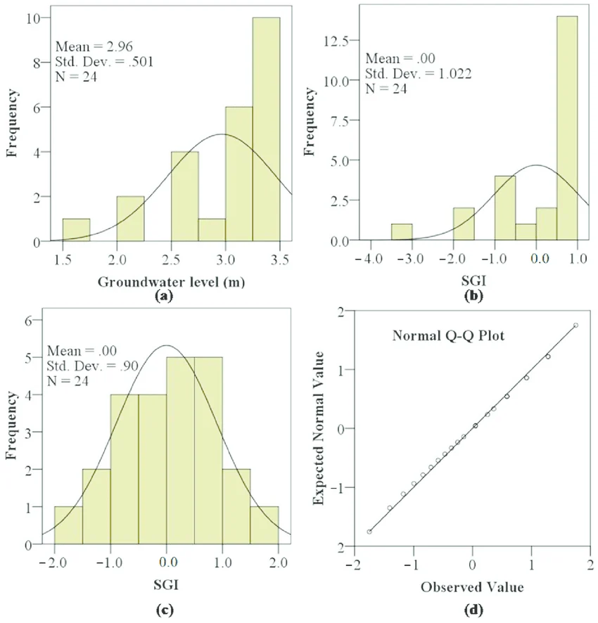
Relationship Between TDS and Groundwater Level

The scatter plot illustrates the relationship between Total Dissolved Solids (TDS) and groundwater levels. Higher TDS values indicate greater concentrations of dissolved minerals in water. The graph suggests that water quality may vary with groundwater depth in some regions.
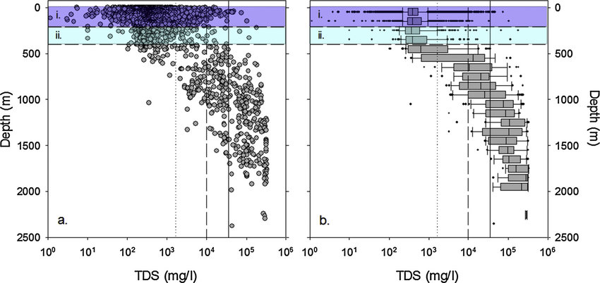

Water Quality Classification
The water quality classification chart shows the distribution of groundwater samples across different water quality categories
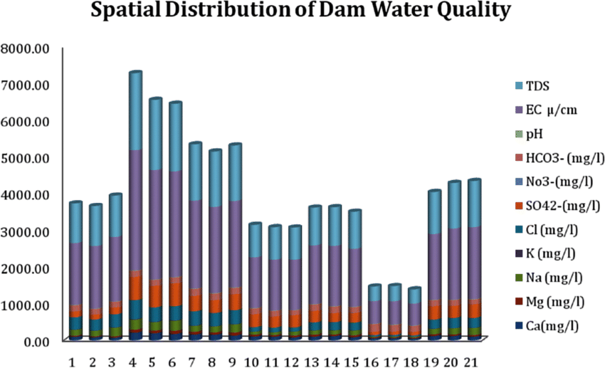

6. Groundwater Conservation Methods
Groundwater conservation is essential for maintaining sustainable water resources. Several strategies can help reduce groundwater depletion and protect water quality.

Rainwater Harvesting
Rainwater harvesting involves collecting and storing rainwater for groundwater recharge. This method allows excess rainfall to infiltrate the ground and replenish aquifers.

Artificial Recharge Techniques
Artificial recharge structures help increase groundwater recharge rates. Common techniques include:
- recharge wells
- percolation tanks
- check dams
- infiltration basins
These systems allow surface water to enter underground aquifers more efficiently.

Efficient Irrigation Practices
Agriculture is one of the largest consumers of groundwater. Efficient irrigation methods such as drip irrigation and sprinkler systems reduce water wastage and minimize groundwater extraction.

Pollution Control
Industrial waste disposal and excessive fertilizer use can contaminate groundwater. Proper waste management and environmental regulations help protect groundwater quality.

Public Awareness and Policy Implementation
Government policies and community awareness programs play an important role in groundwater conservation. Sustainable water management requires cooperation between scientists, policymakers, and local communities.

7. Conclusion
Groundwater is a critical resource that supports drinking water supply, agriculture, and economic development. However, increasing demand and environmental pressures have created serious challenges for groundwater sustainability.
This research analyzed groundwater level and hydrochemical parameters using data science techniques. The analysis demonstrated that groundwater quality varies across regions and is influenced by multiple environmental factors.
Hydrochemical analysis helps identify water quality conditions and detect potential contamination risks. By combining environmental science with data analysis tools, researchers can gain valuable insights into groundwater behavior.
In addition, groundwater conservation methods such as rainwater harvesting, artificial recharge, and sustainable irrigation practices can help protect groundwater resources for future generations.
Continued monitoring and responsible management of groundwater are essential to ensure long-term water security and environmental sustainability.
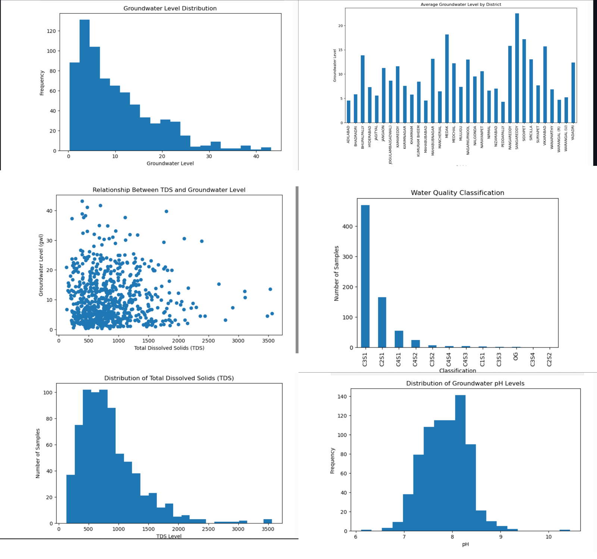

References
- ISCA Research Journal of Engineering Sciences (2014). Groundwater Quality Analysis Study.
- Australian Government (2009). Groundwater Sampling and Analysis Field Guide.
- National Ground Water Association Journal (1999). Groundwater Monitoring and Analysis Techniques.
- ASCE Journal of Environmental Engineering (1992). Hydrochemical Analysis of Groundwater Systems.
- ScienceDirect (2023). Sustainable Groundwater Management and Conservation Techniques.
- ScienceDirect (2023). Methods for Groundwater Conservation and Environmental Protection.

